

SCHOOL OF PURE COMPUTING AND INFORMATICS DEPARTMENT OF ENTERPRISE COMPUTING

PROJECT TITLE:
KUKENA SACCO LTD FLEET MANAGEMENT INFORMATION SYSTEMS
ONLINE TRANSPORT BOOKING SYSTEM

NAME: MUGO NJAUH
REG. NO: BBIT11201657
PROJECT SUPERVISOR: BERNARD CHOGI

This submission is in partial fulfillment of the requirements for the BACHELOR OF BUSINESS INFORMATION TECHNOLOGY in Mount Kenya University.

SERIES: MAY/AUGUST 2026

DECLARATION

This proposal/project is my original work and has not been presented for a degree in any other University
Name: .................................................................
Signature: ....................................
ID No.: ……………………………
Date: ……........................................

CERTIFICATION BY SUPERVISOR

I the undersigned do hereby certify that this is a true report for the project undertaken by the above named student under my supervision and that it has been submitted to Mount Kenya University with my approval

Signature.................................................. Date.........................................

DEDICATION:

I dedicate this work to my ever loving wife and my sister for their support financially, morally and in prayers. It is also a special dedication to all who have contributed in one way or the other to the successful completion of the course.

ACKNOWLEDGEMENT
I would like to express my gratitude to my research supervisor, Mr. Chogi for his invaluable advice, guidance and his enormous patience throughout the development of the research. In addition, I would like to express my gratitude to my loving wife, sister and friends who have helped and given me encouragement in my course work. Finally, I thank the Almighty God for His word, deeds, thoughts and ways.

ABSTRACT
Online Transport Booking System is a database information system, which uses multi-user environment concept through the client or server networks. The main objective of this system is to tidy up in system management and smooth recording process to make it more systematic about the transport booking system. The system focuses on management of transport booking at Kukena Sacco Ltd.
Before that, Kukena Sacco Ltd used traditional system such as use of a forms to make their booking. Traditional system has many problems to the user and management where the user must fill in the booking form first and then must see Head of Department to get approval. If the Head of Department approves the booking, the user must go to Development Department to get an approval from Director or Official Executive. So, this back and forth problem solved with Online Transport Booking System where the user makes a booking online.
After visiting the website, Main Menu will appear on the screen where the user will choose either to check transport schedule, booking or check booking status. So that the user can make the booking with ease thereby saving time. Besides that, the system can create a report and show the statistic about transport booking that helps management such as Development Department to manage the booking of transport more efficiently.
The methodology applied in this system is the System Analysis and Design methodology. With the development at this system, it is hoped that the transport management can manage the transport booking easily and quickly.

DECLARATION i
CERTIFICATION BY SUPERVISOR ii
DEDICATION: iii
ACKNOWLEDGEMENT iv
ABSTRACT vi
CHAPTER 1: INTRODUCTION 9
1.0 Introduction 9
1.2 History and Project Background 9
1.3 Problem Formulation 10
1.4 Objectives 11
1.4.1 General Objective 11
1.4.2 Specific Objectives 11
1. 1.5 Scope and Limitations of the Study 11
1.1.5. 2 What the Proposed System Will Not Do 13
1.1.5.3 System Boundaries 13
1.5.1 Limitations 14
1.5.3 Project Justification 14
1.6. Project Risks and Mitigation 14
1.7 Project Schedule 15
1.8 Conclusion 15
CHAPTER 2: LITERATURE REVIEW 16
2.0 Introduction 16
2.1 Online Transport Booking System 16
2.1.1 Main Features of an Online Transport Booking System 16
2.1.2 Benefits of Online Transport Booking Systems 16
2.1.3 Typical Modules of an Online Transport Booking System 17
2.2 Fleet Management Information Systems 17
2.3 Technologies Used in Online Transport Systems 18
2.3.1 Front-End Technologies 18
2.3.2 Back-End Technologies 18
2.3.3 Database Management Systems 18
2.3.4 Payment Integration Technologies 19
2.4 Related Case Studies 19
2.4.1 Redbus (India) 19
2.4.2 Link Bus Services (Uganda) 20
2.4.3 Academic Bus Reservation Systems 20
2.5 Software and Development Tools 20
2.5.1 Open Source Technologies 20
2.6 Conclusion 21
CHAPTER THREE: METHODOLOGY 22
3.0 Introduction 22
3.1. System Methodology model 22
3.1.1 Waterfall development methodology 23
Fig.3.1.1 Waterfall development methodology 23
3.1.2 Definition Study / Analysis 23
3.1.2.1 Basic Design 23
3.1.2.2 Technical Design / Detail Design 23
3.1.2.3 Construction / Implementation 23
3.1.2.4. Testing 23
3.1.2.5. Integration 24
3.1.2.6. Management and Maintenance 24
3.1.3.a. Advantages of waterfall model 24
3.1.3.b. Disadvantage of Waterfall model 24
3.2 System Architecture 24
3.3 Key Modules 24
3.4 Security Measures 24
3.5 TECHNIQUES FOR REQUIREMENTS 25
3.5.0 Requirement identification 25
3.5.1.1 Introduction 25
3.5.1.2 Data collection tools 25
3.5.1.2.1 Observation 25
3.5.1.2.2. Questionnaire 26
3.5.1.2.3 Interview 27
3.1.4. Secondary data collection 28
3.5.1 Requirements Investigation 28
3.5.1.1 Introduction 28
CHAPTER FOUR: SYSTEM ANALYSIS AND REQUIREMENT MODELLING 29
4.0 Introduction 29
4.1 Current System Analysis 29
4.2 The proposed system 29
4.2.1 System Architecture Diagram 29
Fig 4.1. System Architecture Diagram 30
4.2 UML Use Case Diagram 30
Fig 4.2 UML Use Case Diagram 31
4.2.1 Main Actors 31
4.2.2 Key Use Cases for Customer 31
4.2.3 Key Use Cases for Staff 31
4.2.4 Key Use Cases for Administrator 31
4.3 UML Class Diagram 33
Fig 4.4. UML Class Diagram 33
4.3.1 Main Classes and Attributes 33
4.3.2. Relationship logic 34
4.4 Entity–Relationship Diagram (ERD) 36
Fig 4.6 Entity–Relationship Diagram (ERD) 36
4.4.1 Core Entities 37
4.4.2 Relationships 37
4.5 ERD relationship flow chart 37
4.5.1 Booking Process Flowchart 38
Fig 4.7 Booking Process Flowchart 38
4.5.2 Fleet Management Flowchart 39
Fig 4.7 Fleet Management Flowchart 39
4.6 User Interface Design (Overview) 39
CHAPTER FIVE: SYSTEM DESIGN 40
5.0 Introduction 40
5.1 System Architecture Design 40
5.1.2 Simple Architecture Sketch 40
Figure 5.1.2 Simple Architecture Sketch 40
5.2 User Interface Design 41
5.2.1 Customer Login and Registration Interface 41
Figure 5.2.1 Customer Registration Interface 41
Figure 5.2.2 Customer Login Interface 42
5.2.2 Customer Home (Customer Landing Page) and Booking Interface 42
5.2.2 Customer Home (Customer Landing Page) and Booking Interface 43
Figure 5.2.3 Customer Home (Customer Landing Page) and Booking Interface 43
5.2.4 Customer Booking Interface 43
Figure 5.2.4 Customer Booking Interface 43
5.2.5 The main booking process 44
Fig 5.2.5 The main booking process 44
5.2.3 Staff Authentication Interface 44
Figure 5.2.6 Staff Authentication Interface 44
Figure 5.2.7 Staff Landing Interface 45
5.3 Administrator Dashboard Design 45
Figure 5.3.8 Admin Log In Interface 46
Figure 5.3.9 Admin Landing Interface 46
5.4 Database Design 46
5.4.1 Simplified Database Structure 47
Figure 5.4.0 Simplified Database Structure 47
5.5 System Modules 47
a) User Management Module 47
b) Booking Module 47
c) Fleet Management Module 47
d) Payment Module 47
e) Reporting Module 48
5.6 Security Design 48
5.7 Implementation Environment 48
5.8 System Testing Design 49
5.9 Deployment and Maintenance 49
5.10 Chapter Summary 49
CHAPTER SIX: SYSTEM TESTING AND IMPLEMENTATION 50
6.1 Tools Used for Coding and Testing 50
6.2 System Test Plan 50
6.3 Data Used for Testing 50
6.4 Testing Approach 50
6.5 Proposed Changeover Techniques 51
CHAPTER SEVEN: LIMITATIONS, CONCLUSIONS, AND RECOMMENDATIONS 52
7.1 Limitations 52
7.2 Conclusions 52
7.3 Recommendations 52
7.4 Summary 53
REFERENCES 54
APPENDICES 54
Appendix A: Sample Questionnaire (Requirements Gathering) 54
Appendix B: Sample Screenshots (To be added after prototype) 55
APPENDICES 55
Appendix A: Organizational Structure 55
Appendix B: Documents Reviewed 56
Appendix C: Technical Guide 56
C.1 System Setup 56
C.2 Maintenance Guide 56
Appendix D: User Manual 57
D.1 Basic User Tasks 57
Appendix E: Test Data Summary 58
Appendix F: Graphics and Supporting Charts 59

CHAPTER 1: INTRODUCTION

1.0 Introduction
The transport sector is a key industry to Kenya’s economy. The economic contribution of this sector is enormous, with significant linkages to the manufacturing and services sectors. The transport sector began with importation of vehicles, and then it progressed to assembly operations and the establishment of a wide network of automotive components and parts manufacturers.

1.2 History and Project Background
Kukena SACCO Ltd was established in the year 1998 at the heart of Kirinyaga County. It used to route from Kutus, Kerugoya and Nairobi hence the name KUKENA.
Later it began routing in major towns like Embu, Karatina, Murang’a, Thika and others. After introduction of safety belts and speed governors by the government, many private transport companies emerged. Kukena Sacco booking station is one very successful company offering transport for the public and it credits its success to enormous routes it covers and resourceful and motivated innovation team.
In the recent past, this Sacco has introduced online booking services. The process through which this booking exercise takes place is manual and developments are underway to introduce and implement an online booking system.
Kukena Sacco Booking Station has its booking offices at various major towns in central Kenya and in all the towns that it routes. However, its head offices are located in Kerugoya town Kirinyaga County. Their objective is to provide transport across the country as well as delivering parcels to the clients at their destinations.
Information system has been integrated in the transport sector leading to successful management of business procedures. In this development, a computerized system will be implemented to record all information about Transport Booking System. As to what that informs, a human being is one important player and dominant factor to determine success in an organization. They (human beings) will be implementing the entire plan that has been approved by the administrator.
Online Transport Booking System will be developed at Kukena Sacco Ltd to make sure users make their transport booking process online with facilities provided by this system. At Kukena Sacco Ltd., there are various types of transports available such as vans, buses and coaches. The user who wants to use the transport will make an application for the preferred service. The users are clients of Kukena Sacco Ltd. Therefore, in the system, security aspect will be crucial and the administrator will control it.
In the booking function, user can check whether there is available transport or not and can check their booking status. Another function will be for the administrator to approve the booking, transport and driver record management and producing reports.

1.3 Problem Formulation
Currently, Kukena Sacco Ltd uses a manual system based on pen and paper to make booking and record all information about the transport and driver. The data storage used is manual filing system.
Therefore, Online Transport Booking System will replace the tedious manual system to a computerized system. The manual filing system has many problems to the users and administrators. These problems occur because the application procedure makes use of forms, which after filling and approval, they are filed and stored in a filing cabinet. The forms in a file increase with every other application and they may be hard to find by the management when required. Manual filing system has minimal security and the probability of the files getting lost or misplaced is very high. Manual filing system is therefore not safe nor the best for storing all the data about the transport booking procedures.
Besides, application to make a transport booking also takes a long time because the customer who wants to make the booking must follow tedious procedures to do so. Comparing with Online Transport Booking System, the user will just make the booking online.
The manual filing system is also not systematic because information is difficult to retrieve due to mix-up of data and huge amount of it. It is not well informative e.g. if the users want to check whether there is available transport for them to book there is no way they can get the information from the forms

1.4 Objectives

1.4.1 General Objective
The general objective of this project is to design, develop, code, and implement a web-based Fleet Management Information System and Online Transport Booking System for Kukena SACCO Ltd that improves the efficiency, security, and reliability of transport booking and fleet management services while generating accurate operational reports.

1.4.2 Specific Objectives
The specific objectives of the project are:
- To analyze the existing transport booking and fleet management processes at Kukena SACCO Ltd in order to identify the challenges associated with the current manual system.
- To create a web-based transport booking and fleet management system that allows customers to book transport services online conveniently and securely.
- To design a relational database for storing and managing information relating to customers, bookings, vehicles, drivers, routes, schedules, and payments.
- To develop a user-friendly interface for customers, staff, and administrators to facilitate efficient system interaction.
- To code the system modules for user authentication, online booking, seat selection, payment processing, and fleet management functionalities.
- To develop secure mechanisms for validating booking information, managing transport schedules, and preventing unauthorized system access.
- To generate automated reports on bookings, payments, fleet utilization, and system activities to support managerial decision-making.
- To implement and test the proposed system to ensure that it meets the functional and security requirements of Kukena SACCO Ltd.
- To evaluate the performance of the developed system in improving data integrity, reducing manual paperwork, and enhancing service delivery.

1. 1.5 Scope and Limitations of the Study
The scope of this project is the design, development, implementation, and testing of a web-based Fleet Management Information System and Online Transport Booking System for Kukena SACCO Ltd. The proposed system is intended to automate transport booking and fleet management activities while improving service delivery, data security, and operational efficiency. The system will be accessible through a web browser and will support multiple categories of users, namely customers, staff members, and system administrators.

The proposed system is expected to perform the following functions:

1.1.5.1.1 Customer Functions
The system will enable customers to:
- Register and securely log into their accounts.
- Search for available transport routes and travel schedules.
- View vehicle availability and seat availability in real time.
- Book transport services online.
- Select preferred seats where applicable.
- Make online payments through supported payment platforms such as M-Pesa.
- Receive electronic tickets and booking confirmations.
- View their booking history and travel records.
- Cancel or reschedule bookings subject to the Sacco's booking policies.
- Receive notifications regarding successful bookings and payment confirmations.
- Have a help function in case a customer requires assistance on the interface.

1.1.5.1.2. Staff Functions
The system will enable authorized staff members to:
- Manage customer bookings.
- Verify payments made by customers.
- Confirm and approve transport bookings.
- Manage customer inquiries and booking amendments.
- View daily booking activities.
- Generate operational reports.
- Manage transport schedules and route information.

1.1.5.1.3 Administrator Functions
The system will enable administrators to:
- Manage user accounts and access privileges.
- Register and manage vehicles and drivers.
- Create and update transport routes and schedules.
- Configure transport fares and payment options.
- Monitor all booking activities within the system.
- Generate daily, weekly, monthly, and annual reports.
- Monitor system logs and security activities.
- Manage system backups and maintenance operations.
- Generate fleet utilization and revenue reports for decision-making purposes.

1.1.5.1.4 Fleet Management Functions
The system will further support:
- Vehicle registration and management.
- Driver assignment and management.
- Route and schedule management.
- Fleet utilization monitoring.
- Vehicle maintenance record management.
- Trip logging and transport history management.
- Report generation for transport operations and fleet performance.

1.1.5. 2 What the Proposed System Will Not Do
Despite its capabilities, the proposed system is not expected to perform the following functions:
- Provide real-time GPS tracking of vehicles unless integrated with external GPS hardware.
- Automatically drive or dispatch vehicles without human intervention.
- Support international transport booking services outside Kukena SACCO's registered routes.
- Operate without an internet connection since it is a web-based application.
- Process payments independently without integration with third-party payment gateways.
- Predict traffic conditions or travel delays using artificial intelligence.
- Replace managerial decision-making or human administrative responsibilities.
- Perform advanced accounting functions such as payroll management or complete financial auditing of the Sacco.
- Support airline, railway, or hotel reservation services since it is specifically designed for road transport operations.
- Eliminate the need for system maintenance, user training, and periodic software updates.

1.1.5.3 System Boundaries
The proposed Fleet Management Information System and Online Transport Booking System is limited to the management of transport booking, fleet operations, payment processing, and report generation for Kukena SACCO Ltd. The project focuses on providing a secure, reliable, and efficient platform for managing transport services while reducing manual paperwork and improving customer experience. Any additional functionalities beyond the stated scope will require future system enhancements and integration with external technologies.

1.5.1 Limitations
- The company needs to train the employees on the usage of the proposed system.
- It is expensive to install the proposed system
- Job elimination as technology improves; tasks formerly performed by several human employees will then be performed by the new computer systems.
- Security Breaches: The new system will be vulnerable to security breaches, particularly when they are accessible via the Internet. If appropriate measures are not in place, unauthorized individuals may access confidential data. Information may be altered, permanently destroyed or used for unsavory purposes.

1.5.3 Project Justification
Online Transport Booking System will bring lots of benefit to its users and administrators at Kukena Sacco Ltd such as -
- Globalization: This system will not only make sharing of information between clients and staffs of Kukena Sacco Ltd quick and efficient, but also bring down barriers of linguistic and geographic boundaries.
- Communication: With the use of this proposed system, communication will become cheaper, quicker, and more efficient.
- Cost effectiveness: This system will streamline businesses processes and make them extremely cost effective money making machines.
- More time: This system will make it possible for the business procedures to be open 24/7 all over the country meaning that clients can have goods delivered right to their doorstep

1.6. Project Risks and Mitigation
- Customer’s information may land into the hands of unauthorized persons. Security Procedures will be put in place to prevent unauthorized access to the system.
- Since this system will use internet connection, there is a possibility of malicious software and viruses being a threat to the system. Whitelisting the applications will allow only the required applications to run on the system and none other applications.
- The same data may be repeated many times making it difficult to do a follow-up. Patching up is a piece of software that can be used to update programs and data in the database.

1.7 Project Schedule

ACTIVITY | MAY | JUNE | JULY | AUGUST | SEPT | OCT | NOV | DEC
TITLE
PROPOSAL
FEASIBILTY STUDY
SYSTEM ANALYSIS
SYSTEM DESIGN
CODING AND TESTING
DOCUMENTATION
IMPLEMENTATION

Table1.7 a: Project Schedule

1.8 Conclusion
Online Transport Booking System is developed to make transport booking process easy. To develop this system, files are still used as a reference to yield a system that give satisfaction to the user. The system is also developed to tidy up management system available and improve booking system about transport information. The system is developed in order to overcome the problems faced using the manual way.

CHAPTER 2: LITERATURE REVIEW

2.0 Introduction
This chapter reviews the literature related to online transport booking systems and fleet management information systems. It discusses the concepts, features, benefits, case studies, software technologies, and tools applicable to the proposed Kukena SACCO Ltd Fleet Management Information System and Online Transport Booking System. The review provides the theoretical and technological foundation upon which the proposed system is developed.

2.1 Online Transport Booking System
An online transport booking system is a computerized platform that enables customers to search transport routes, view schedules, reserve seats, make payments, and receive electronic tickets through the internet. Modern transport management systems improve operational efficiency, reduce manual errors, and enhance customer convenience through automation (Stallings, 2020).
The adoption of web-based booking systems has significantly transformed the public transport industry by enabling real-time booking services and centralized data management (Pressman & Maxim, 2020).

2.1.1 Main Features of an Online Transport Booking System
The major features of an online transport booking system include:
- User registration and authentication.
- Route and schedule searching.
- Vehicle and seat availability checking.
- Online transport booking.
- Electronic ticket generation.
- Payment gateway integration.
- Booking management and cancellation.
- Administrative control and report generation.
These functionalities improve customer satisfaction by providing twenty-four-hour access to transport services and minimizing physical interactions during the booking process (Sommerville, 2016).

2.1.2 Benefits of Online Transport Booking Systems
Online transport booking systems provide numerous advantages to both customers and transport operators. Some of these benefits include:
- Reduced paperwork and operational costs.
- Faster booking processes.
- Improved data accuracy and integrity.
- Better fleet utilization.
- Increased customer convenience.
- Enhanced security through authentication mechanisms.
- Automated reporting and record management.
- Real-time access to transport schedules and booking information.
According to Sommerville (2016), information systems increase organizational productivity by automating business processes and improving decision-making capabilities.

2.1.3 Typical Modules of an Online Transport Booking System
A modern transport booking system typically consists of the following modules:
- Customer Management Module.
- User Authentication Module.
- Transport Booking Module.
- Payment Processing Module.
- Vehicle and Fleet Management Module.
- Route and Schedule Management Module.
- Reporting and Analytics Module.
- Administrative Management Module.
The modular approach enhances system scalability and simplifies maintenance and future upgrades (Pressman & Maxim, 2020).

2.2 Fleet Management Information Systems
Fleet Management Information Systems are computerized solutions designed to monitor, manage, and optimize transport operations. They assist organizations in managing vehicles, drivers, maintenance schedules, fuel consumption, and operational reports.
Fleet management systems enable transport organizations to improve vehicle utilization, reduce maintenance costs, and enhance service delivery. They also provide managers with analytical reports that support strategic decision-making (Rodrigues, 2021).
The proposed system for Kukena SACCO Ltd integrates fleet management functionalities with online transport booking services to improve transport operations.
The fleet management functionalities include:
- Vehicle registration and management.
- Driver management.
- Route allocation.
- Vehicle maintenance scheduling.
- Trip logging.
- Fleet utilization monitoring.
- Operational report generation.

2.3 Technologies Used in Online Transport Systems
The development of web-based transport booking systems requires various technologies that support front-end development, back-end processing, database management, and secure payment integration.

2.3.1 Front-End Technologies
Front-end technologies are responsible for the user interface and user experience of the system. Common technologies include:
- HTML5.
- CSS3.
- JavaScript.
- Bootstrap.
- React.js.
These technologies provide responsive and interactive interfaces that improve usability across different devices (Duckett, 2021).

2.3.2 Back-End Technologies
The back-end layer processes business logic and handles communication between users and the database.
Common back-end technologies include:
- PHP.
- Laravel Framework.
- Node.js.
- Python (Django and Flask).
PHP remains one of the most widely used server-side scripting languages for web application development due to its simplicity and compatibility with multiple platforms (Nixon, 2021).

2.3.3 Database Management Systems
Database Management Systems are used for storing and managing application data.
Examples include:
- MySQL.
- PostgreSQL.
- MongoDB.
MySQL is widely preferred because it is open-source, reliable, scalable, and compatible with most web application frameworks (DuBois, 2021).
The proposed system will utilize MySQL for managing:
- Customer records.
- Vehicle records.
- Driver information.
- Booking details.
- Payment transactions.
- Transport schedules.
- Fleet utilization reports.

2.3.4 Payment Integration Technologies
Online payment systems enhance customer convenience by enabling secure financial transactions.
The proposed system supports payment gateway integration such as:
- M-Pesa.
- Debit cards.
- Credit cards.
- Online banking services.
Mobile payment technologies have become increasingly popular in Kenya because they provide secure and convenient methods for processing transport bookings (Safaricom PLC, 2025).

2.4 Related Case Studies
Several organizations have successfully implemented online transport booking systems.

2.4.1 Redbus (India)
Redbus is one of the world's largest online bus ticket booking platforms. The company digitized bus transport services by providing:
- Online ticket booking.
- Seat selection.
- Payment processing.
- Route management.
- Electronic ticket generation.
The platform significantly improved customer convenience and operational efficiency within India's transport sector.

2.4.2 Link Bus Services (Uganda)
Link Bus Services introduced web-based booking services that enable passengers to reserve transport services remotely. The system improved ticket management and reduced congestion at booking terminals.

2.4.3 Academic Bus Reservation Systems
Several academic studies have proposed and implemented online bus reservation systems using PHP and MySQL technologies. These systems demonstrate the effectiveness of web-based technologies in managing passenger bookings and transport operations while reducing manual processes (IJARIIE, 2021).

2.5 Software and Development Tools
The development tools proposed for the Kukena SACCO system include:
- Visual Studio Code.
- PHP.
- HTML5.
- CSS3.
- JavaScript.
- MySQL.
- Apache Web Server.
- WampServer.
- Git and GitHub.
These tools provide a cost-effective environment for developing, testing, and deploying transport management systems.

2.5.1 Open Source Technologies
Open-source software provides organizations with:
- Lower development costs.
- Greater customization capabilities.
- Community support.
- Improved scalability.
Open-source technologies are particularly suitable for academic and small-to-medium enterprise projects because they eliminate licensing costs while offering extensive development capabilities (Nixon, 2021).

2.6 Conclusion
The literature reviewed indicates that online transport booking and fleet management systems significantly improve operational efficiency, customer satisfaction, and data management. The integration of web technologies, database management systems, and secure payment platforms provides organizations with reliable and scalable transport solutions.
The proposed Kukena SACCO Ltd Fleet Management Information System and Online Transport Booking System adopts industry-standard technologies and best practices to address the challenges associated with manual transport booking processes.

CHAPTER THREE: METHODOLOGY

3.0 Introduction
This phase focuses on designing an information system that satisfies the criteria specified in the analysis. It involves the translation of the system specifications in the analysis phase into a technical specification for implementation. It’s a description of the model and framework under which the system is to be developed. The document describes how the system will be built and it’s a clear insight of the system concepts and operations of the final product. It portrays the developers understanding of the issued user requirements and gives a foresight of what is to be expected such that changes can be easily made before the final system is implemented.
The use of methodology helps to produce a better quality product to ensure that user requirements are met completely. Besides that, a good methodology chosen will be a systematic guidance on how to develop software successfully, where the guidance manifest with proven approaches, best practices, guideline, techniques and sequences. A methodology is important for managing and controlling a researching order to achieve the specified objectives within a given time.

3.1. System Methodology model
The system will be designed and implemented using the waterfall model. Waterfall model is a version of the systems development life cycle model software engineering. It describes a development that is linear and sequential and that one stage is completed before the next stage of development.

3.1.1 Waterfall development methodology

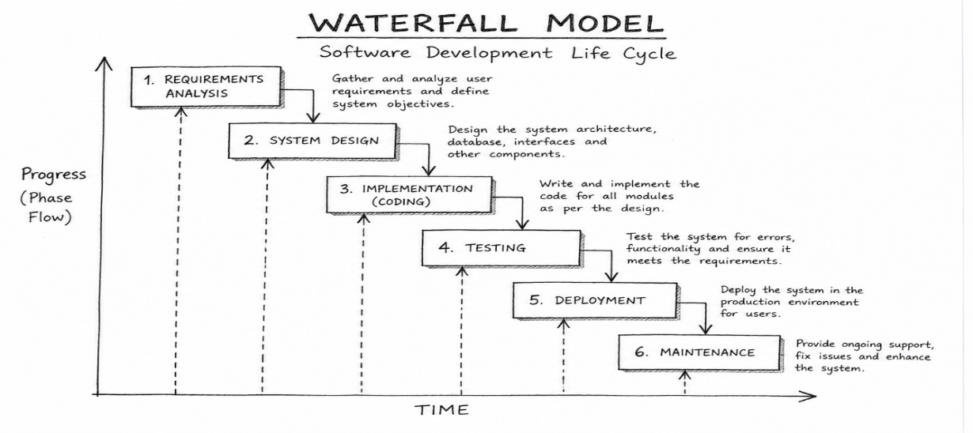

Fig.3.1.1 Waterfall development methodology

3.1.2 Definition Study / Analysis
During this phase research is being conducted which includes brainstorming about the software, what it is going to be and what purpose is it going to fulfill.

3.1.2.1 Basic Design
If the first phase gets successfully completed and a well thought out plan for the software development has been laid, the next step involves formulating the basic design of the software on paper.

3.1.2.2 Technical Design / Detail Design
After the basic design gets approved, then a more elaborated technical design can be planned. Here the functions of each of the part are decided and the engineering units are placed for example modules, programs etc.

3.1.2.3 Construction / Implementation
In this phase the system interface is to be built and source code of the programs written.

3.1.2.4. Testing
The system design and construction is to be tested and checked for errors. Errors have to be handled in case they manifest.

3.1.2.5. Integration
In the phase of Integration, the company puts it in use after the system has been successfully tested.

3.1.2.6. Management and Maintenance
Maintenance and management is needed to ensure that the system will continue to perform as desired.

3.1.3.a. Advantages of waterfall model
1. Verification at each stage allows early detection of errors and misunderstanding.
2. Allows departmentalization and managerial control.
3. Helps to plan and schedule the project.

3.1.3.b. Disadvantage of Waterfall model
The disadvantage of waterfall development is that it does not allow for much reflection or revision. Once an application is in the testing stage, it is very difficult to go back and change something that was not well-documented or thought upon in the concept stage.
3.2 System Architecture
The system will follow a three-tier architecture:
- Presentation layer (user interface)
- Application layer (business logic)
- Data layer (database)

3.3 Key Modules
- User management
- Booking system
- Fleet management
- Payment processing
- Reporting and analytics

3.4 Security Measures
- User authentication and authorization
- Data encryption
- Secure payment integration
- Regular system backups

3.5 TECHNIQUES FOR REQUIREMENTS

3.5.0 Requirement identification

3.5.1.1 Introduction
The requirements identification section looks at the data collection tool of choice and examines the reason behind the use of those particular tools and how the population to sample was identified. The decision to interview villa owners and attendants was because this is the people that the management system is meant for.

3.5.1.2 Data collection tools
The data collection tools of choice were interviews and questionnaires;
The techniques that were used to collect data for the system from both the customers and staffs included:

3.5.1.2.1 Observation
With observations, processes are observed in their natural working environment. Observations can be overt whereby everyone knows they are being observed or covert where no one knows they are being observed and the observers are concealed. With covert observation, people are more likely to behave naturally if they do not know they are being observed. However, you will typically need to conduct overt observations because of ethical problems related to concealing your observation.
We can also do an observation directly or indirectly i.e.
Direct observation is when you watch/look at interactions or behaviors as they occur. Indirect observations are when you watch the results of interactions, processes, or behaviors.
This involved observation of the activities that are carried out at the place of work for the study. The officials of the Company noted some complex tasks in the receiving of the application from various clients.
Benefits of the technique:
- It is not expensive.
- Data gathering can be highly reliable.
- The system is able to see exactly what is being done.
Limitations of the technique:
- People may feel uncomfortable when being observed.
- Attitudes cannot be studied with the help of observations.
- Observation involves a lot of time as the observer has to wait for an event to occur to study that particular event

3.5.1.2.2. Questionnaire
The questionnaires were used to collect customer’s feedback about the system through asking questions. Both closed and open ended questionnaires were used by the company as data collection tools. The questions were presented to the staff members hence facilitating a fast acquisition of information.
Sample questionnaire
- Can I book for a driver?
- How can I pay for my booking?
- Can I amend a confirmed booking?
- How long can I stay with a rented car?
Benefits:
- It allows for reference in documents and documentation.
- It is free of interviewer distortion and error.
- The questionnaire can be administered to large number of people at the same time.
- It is relatively cheap.
- Allows one to get a picture of some of the problems and be able to formulate some of the requirements of the new system.
- Enables developers to create a mental picture of the design of the system which will be easy to implement it than form the user point of view of the design, which might be ambiguous.
- Collect data where and when an event or activity is occurring.
- Does not rely on people’s willingness or ability to provide information.

Limitations:
- Low response rates to the questionnaire may lead to unrepresentative responses being analyzed to draw incorrect conclusions.
- Lack of direct contact may mean that questions are interrupted the wrong way.
- No possibility of the analyst observing the users work place or work practice.
- Expensive and time-consuming compared to other data collection methods.
- Does not increase your understanding of why people behave as they do.
- Risk observer bias.

3.5.1.2.3 Interview
An interview is a direct and interesting way of cutting to the heart of the matter. By interviewing the intended user of the system, I am able to gauge their attitude toward the creation or the availability of a resource management system based on their reactions which ranges from curious, interested and enthusiasm.
This will involve face to face interaction with the customers and staffs. The researcher will use the same interview questions in the research to compare the feedback from customers and staffs.
Interview questions
- What happens if the car gets spoilt?
- What documentation do I need to take with me to the booking desk?
- What are cross border or territorial restrictions?
- What is fuel policy?
Benefits:
- They provide instant feedback.
- There is closer contact between interviewer and interviewee.
- It helps overcome the fears and resistance to change that may be felt by the employee and to gain trust.
- Produce a higher response rate.
- Does not necessarily reading skills to answer a questionnaire.
- Are useful for dealing with complex topics.
- The Interviewer can probe deeper into a response given by an interviewee.

Limitations:
- It is very time consuming and therefore costly.
- It may be impractical due to the location of interviewee.
- Not used for a large number of people
- The interviewer can affect the data if he/she is not consistent.
- The Interviewer may be biased and ask closed questions

3.1.4. Secondary data collection
Secondary data is the data that have already been collected by others and readily available from other sources e.g. books, journals, magazines, internet etc. Such data are cheaper and more quickly obtainable than the primary data and also may be available when the primary data cannot be obtained at all.

3.5.1 Requirements Investigation

3.5.1.1 Introduction
Requirements investigation involves evaluating the data gathered and the sample population response to establish whether the creation of the system is justified.
Analysis of the data collected
From the data collected, it is clear that though the management have their way of managing resources (ways that include word of mouth, posters and handwritten materials), they do not have an established and scheduled way of managing different resources.
Observation
It is clear that from the survey carried out, a reliable low cost system needs to be established that manages the booking process, vehicle availability, client and staff, with a defined link between the entities in the business process.
Problem identified from the data collected
A lot of paperwork and manual data collection, storage, retrieval, update and report generation with limited aid of electronic calculators, excel sheets and pen and paper mode of operation.
Service delivery is seriously affected by the operational and managerial inefficiencies inherent in the current manual system.

CHAPTER FOUR: SYSTEM ANALYSIS AND REQUIREMENT MODELLING
4.0 Introduction
this chapter presents the system analysis and requirement modelling for the Kukena Sacco ltd fleet management and online transport booking system. It describes the overall architecture, main modules, database design, and key Unified Modeling Language (UML) diagrams that guide implementation.

4.1 Current System Analysis
The current booking system at Kukena SACCO is largely manual. Customers visit booking offices physically to reserve seats or transport services. The booking clerk records customer details manually using booking forms. Information is stored inside filing cabinets. Payments are confirmed manually before tickets are issued. When management requires reports, employees search through files manually.

4.2 The proposed system
The proposed system adopts a three-tier web-based architecture consisting of:
- Presentation layer: A web interface accessed via browsers (PC and mobile) by customers, staff, and administrators.
- Application layer: A server-side application (e.g. PHP or Node.js) implementing business logic for booking, fleet management, payments, and reporting
- Data layer: A relational database (e.g. MySQL) storing users, vehicles, routes, bookings, payments, and audit logs
- Data flows from the client browser to the web server over HTTPS, which processes requests, accesses the database, and returns dynamic responses.

4.2.1 System Architecture Diagram
Below is an architecture diagram showing:
- Actors: Customer, Staff, Administrator
- Web browser (client)
- Web server and application server
- Database server (MySQL)
- External payment gateway (M-Pesa API)
CUSTOMER
WEB BROWSER: CLIENT
STAFF

ADMINISTRATOR
WEB SERVER
(Apache/WAMP)
APPLICATION SERVER
(PHP Backend)
MySQL DATABASE
(Bookings, Users)
M-Pesa API GATEWAY
(External Payment)

Fig 4.1. System Architecture Diagram

4.2 UML Use Case Diagram
CUSTOMER
(Register/Login)
(Search Routes)
(View Schedule)
(Select Seat)
(Book Ticket)
(Make Payment)
(Receive E-Ticket)
(View Booking History)
(Cancel Booking)

STAFF
(Login)
(Search Routes)
(View Bookings)
(Verify Payments)
(Confirm Booking)
(Manage Routes)
(Generate Reports)
ADMINISTRATOR
(Login)
(Manage Users)
(Manage Staff)
(Manage Vehicles)
(Manage Routes)
(Manage Drivers)
(Approve Bookings)
(Generate Reports)
(System Configuration)
ONLINE TRANSPORT BOOKING SYSTEM

Fig 4.2 UML Use Case Diagram

4.2.1 Main Actors
- Customer (Passenger)
- Staff (Booking clerk or Sacco officer)
- Administrator (System admin/manager)

4.2.2 Key Use Cases for Customer
- Register account and log in
- View routes and schedules
- Check seat and vehicle availability
- Make a booking
- Make online payment (M-Pesa / card)
- View booking history and e-ticket
- Cancel booking (subject to policy)

4.2.3 Key Use Cases for Staff
- Create and manage bookings for walk-in customers
- Manage customer profiles
- Print tickets and receipts
- Handle booking amendments and refunds

4.2.4 Key Use Cases for Administrator
- Manage user accounts and roles
- Create and manage vehicles, drivers, routes, and schedules
- Configure fares and payment options
- View and generate operational reports (daily, weekly, monthly)
- Monitor system logs and security events
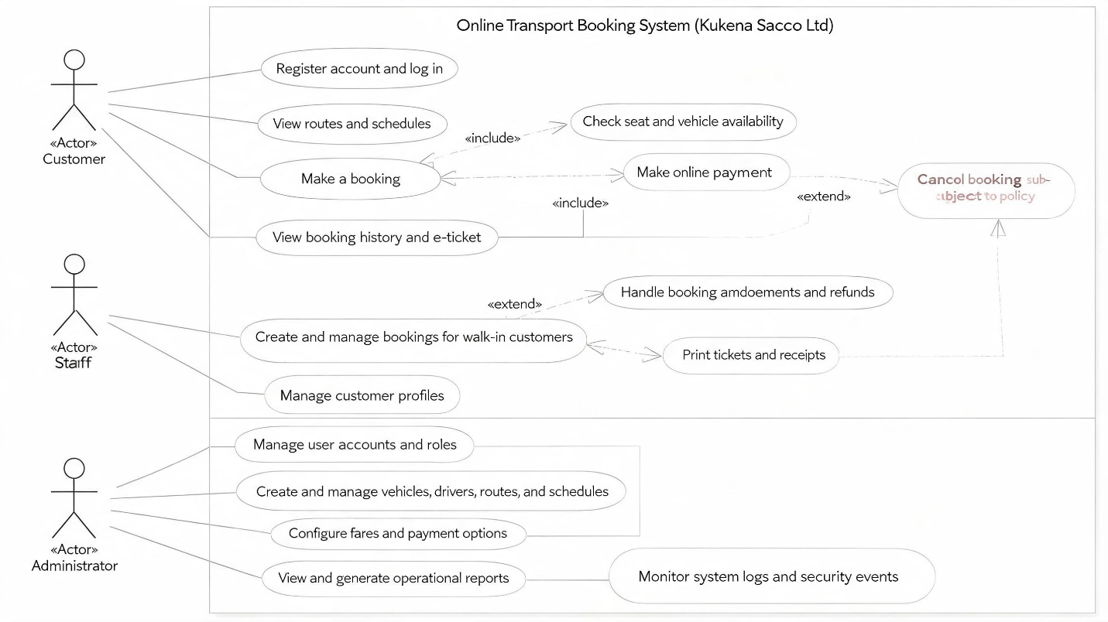Fig 4.3 Key Use Cases for Administrator

4.3 UML Class Diagram
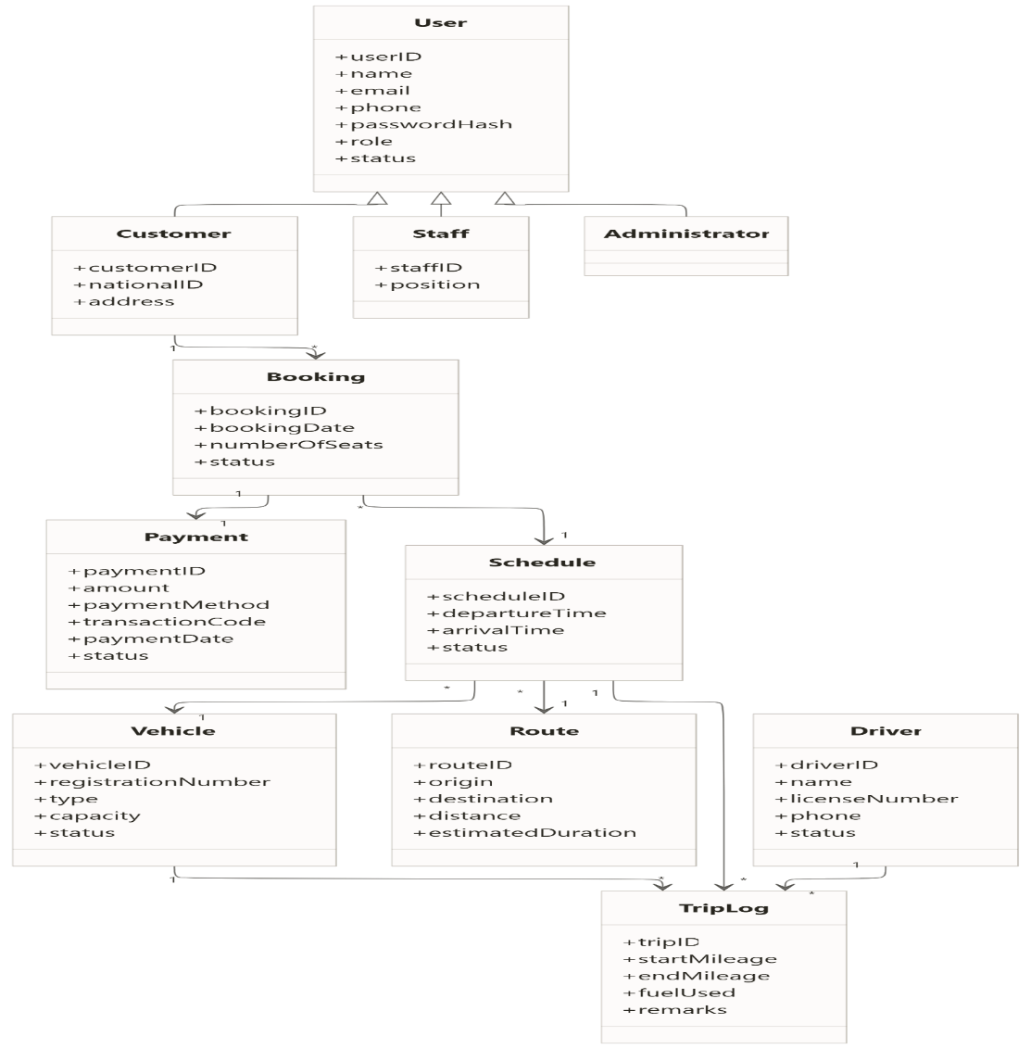

Fig 4.4. UML Class Diagram

4.3.1 Main Classes and Attributes
Suggested core classes:
- User
  - userID, name, email, phone, passwordHash, role, status
- Customer (inherits User)
  - customerID, nationalID, address
- Staff (inherits User)
  - staffID, position
- Administrator (inherits User)
- Vehicle
  - vehicleID, registrationNumber, type, capacity, status
- Route
  - routeID, origin, destination, distance, estimatedDuration
- Schedule
  - scheduleID, routeID, vehicleID, departureTime, arrivalTime, status
- Booking
  - bookingID, customerID, scheduleID, bookingDate, numberOfSeats, status
- Payment
  - paymentID, bookingID, amount, paymentMethod, transactionCode, paymentDate, status
- Driver
  - driverID, name, licenseNumber, phone, status
- TripLog / FleetRecord
  - tripID, vehicleID, driverID, scheduleID, startMileage, endMileage, fuelUsed, remarks
Associations should model relationships such as:
- One Customer can have many Bookings.
- One Booking relates to one Schedule.
- One Schedule uses one Vehicle and one Route.
- One Booking has one Payment.
- One Vehicle can have many TripLogs.
Below is a class diagram showing classes, attributes, and multiplicities (1..*, 0..1, etc.)

4.3.2. Relationship logic
- One Customer can make many Bookings.
- One Booking belongs to exactly one Schedule.
- One Booking has one Payment.
- One Schedule uses one Vehicle and one Route.
- One Vehicle can have many TripLogs.
- One Driver can appear in many TripLog
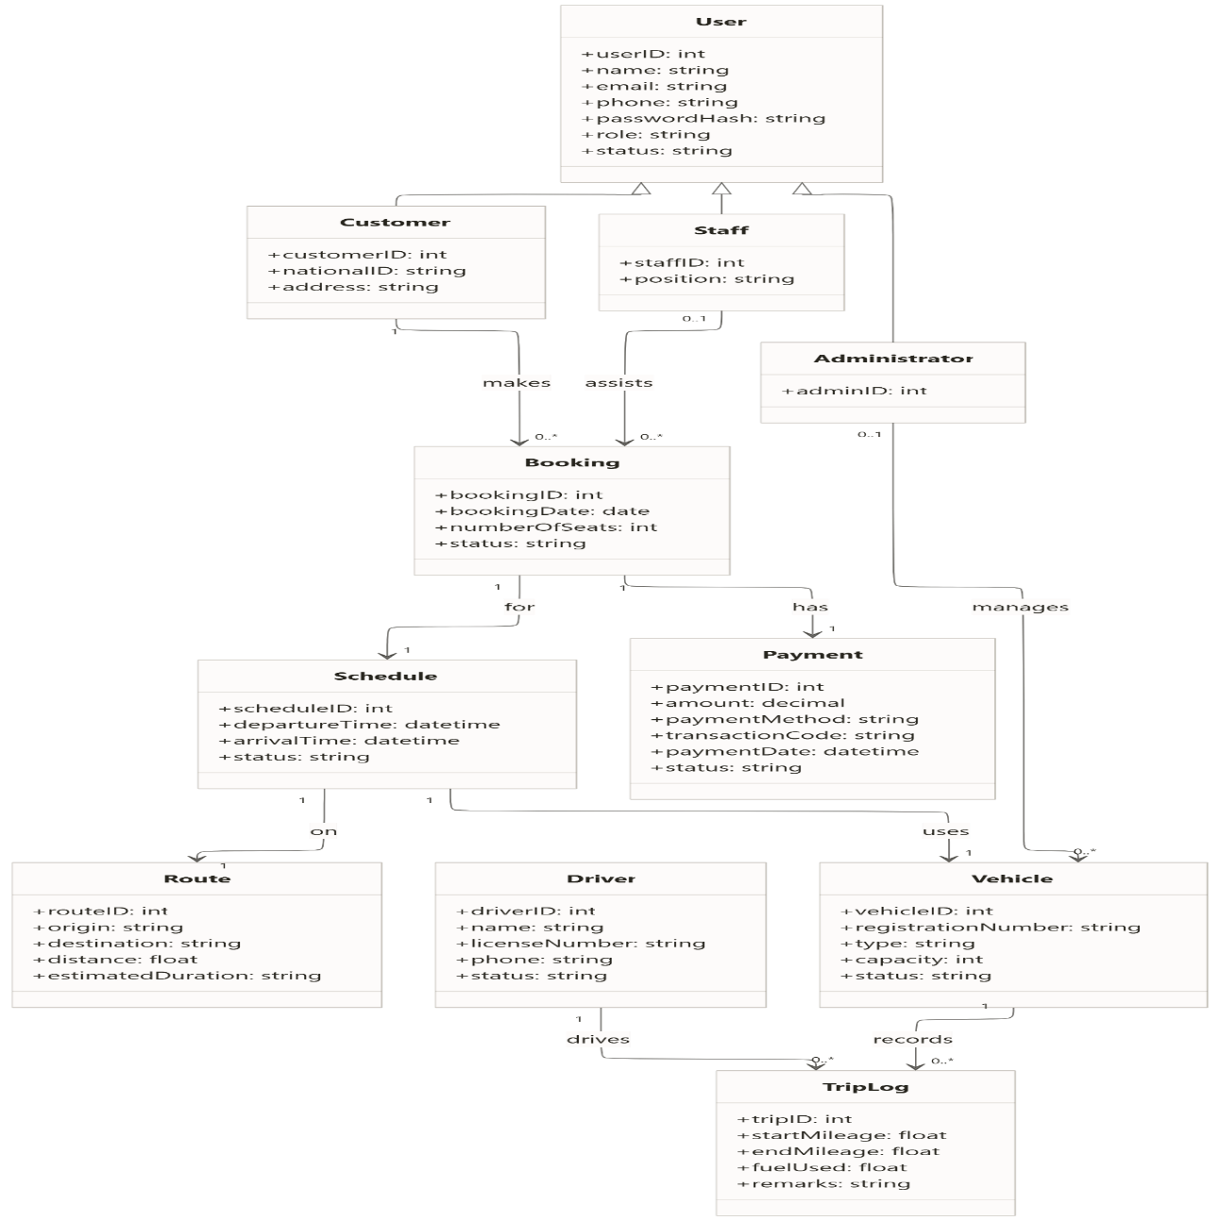Fig. 4.5. Relationship logic

4.4 Entity–Relationship Diagram (ERD)
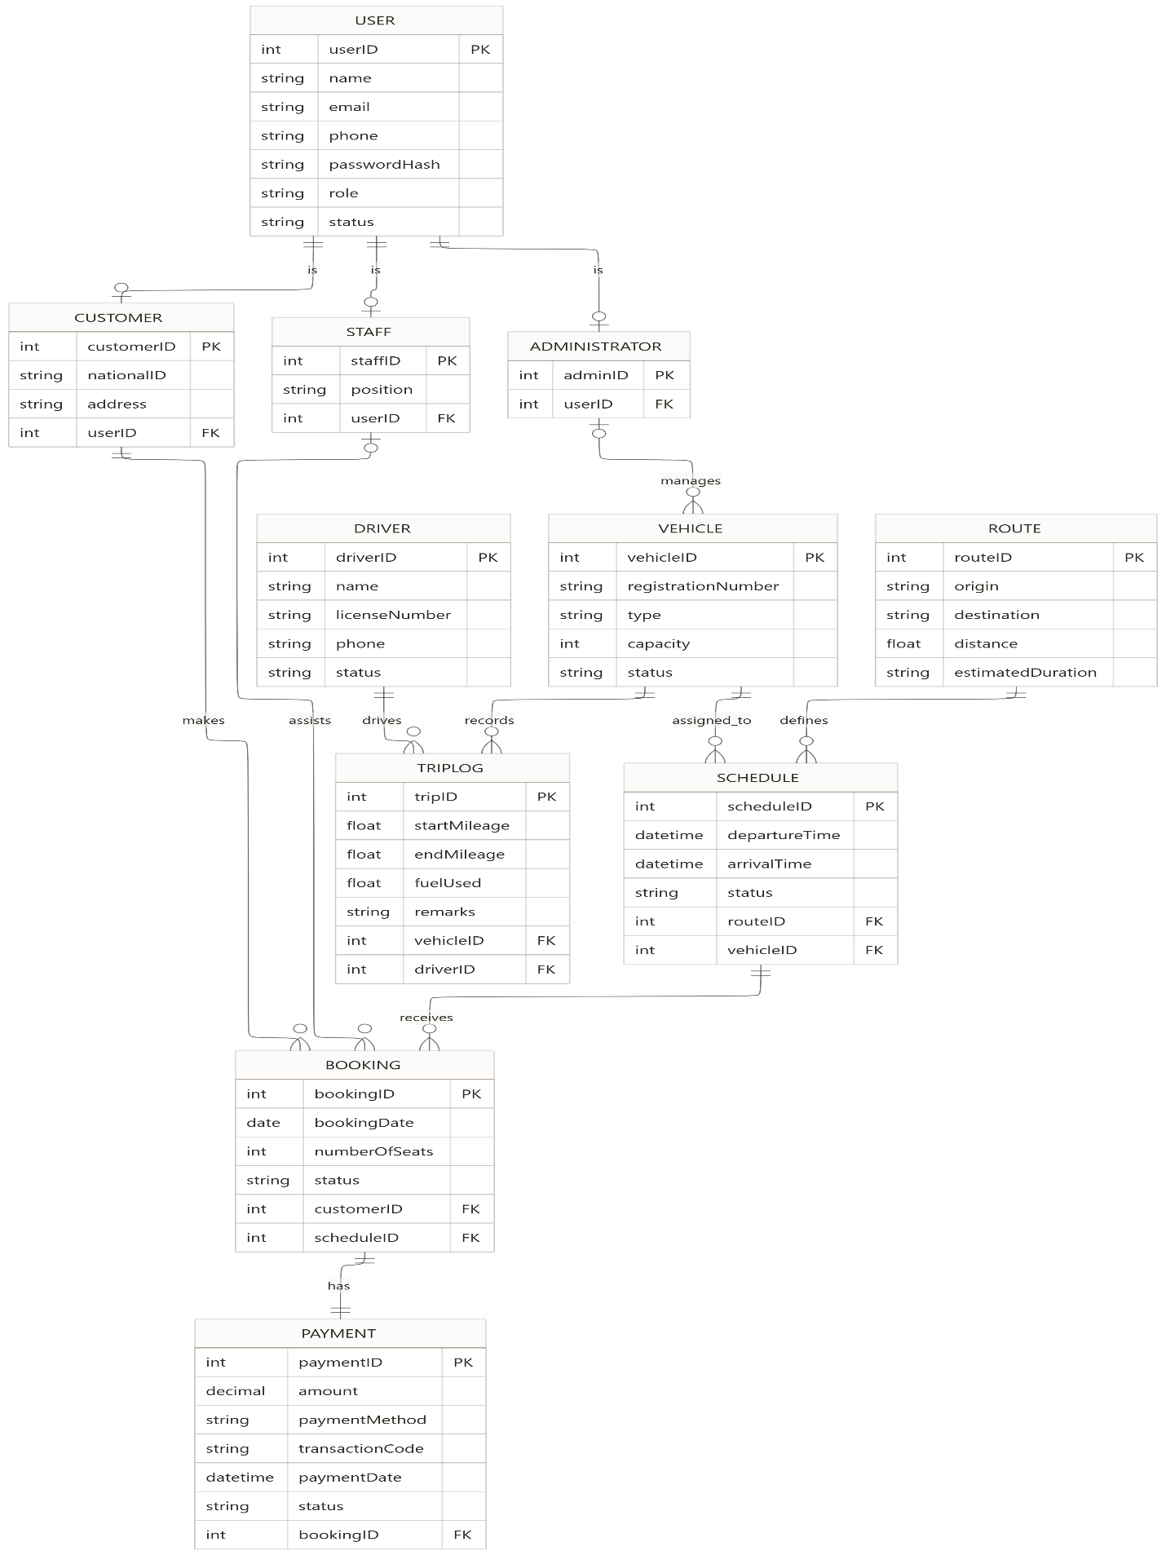

Fig 4.6 Entity–Relationship Diagram (ERD)

4.4.1 Core Entities
Map the core classes into database tables: USER, CUSTOMER, STAFF, VEHICLE, ROUTE, SCHEDULE, BOOKING, PAYMENT, DRIVER, TRIP_LOG.

4.4.2 Relationships
- CUSTOMER (1) – (N) BOOKING
- SCHEDULE (1) – (N) BOOKING
- VEHICLE (1) – (N) SCHEDULE
- DRIVER (1) – (N) (N) SCHEDULE
- STAFF (1) - (N) BOOKING
ERD RELATIONSHIP DIAGRAM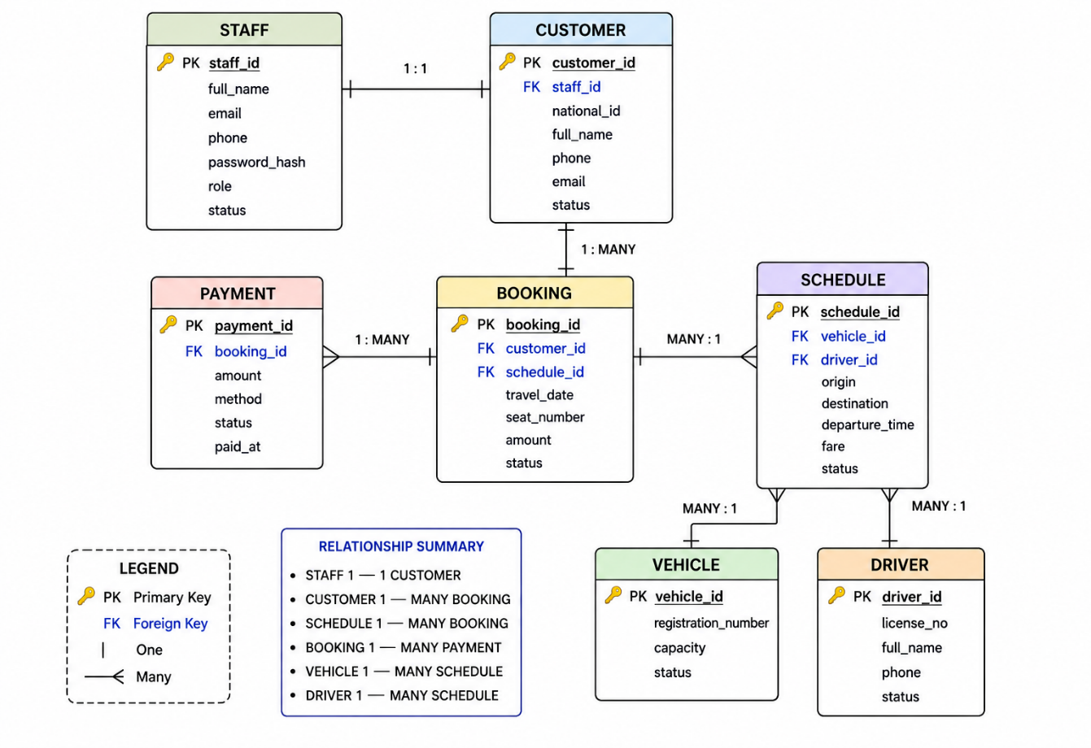

4.5 ERD relationship flow chart
The ERD should indicate primary keys (PK), foreign keys (FK), and important attributes such as constraints on uniqueness (e.g. registrationNumber unique).

4.5.1 Booking Process Flowchart
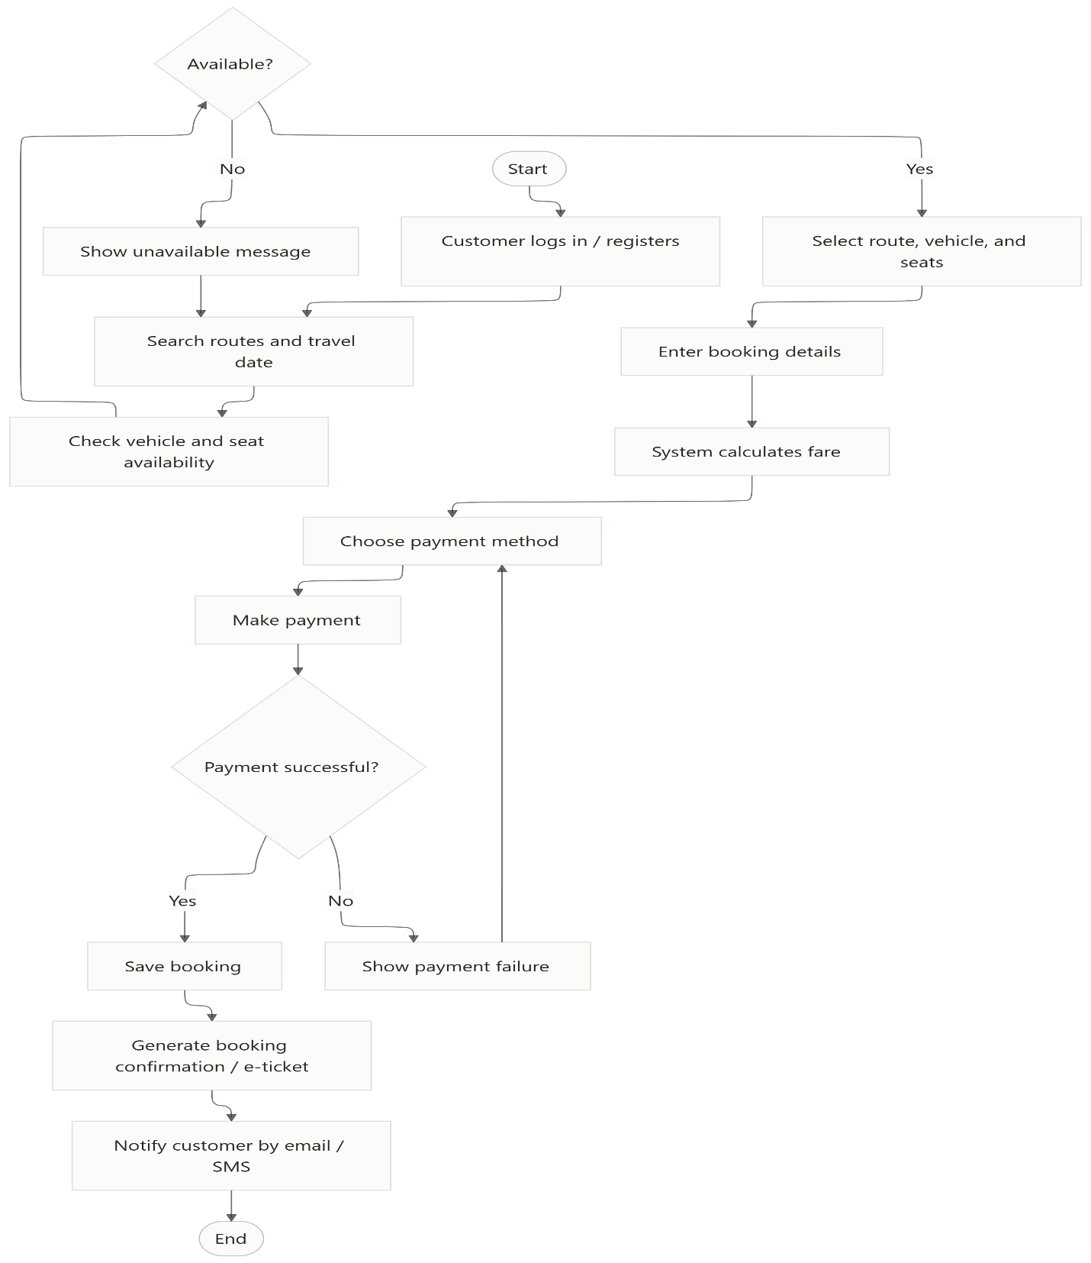

Fig 4.7 Booking Process Flowchart
Main steps:
- Customer logs into the system.
- Customer searches for route and date.
- System displays available schedules and seats.
- Customer selects schedule and seats.
- System calculates fare and presents payment options.
- Customer confirms and pays via mobile money or card.
- System verifies payment with payment gateway.
- If successful, booking is confirmed and e-ticket generated; else, customer is prompted to retry

4.5.2 Fleet Management Flowchart
Main steps: 2 Fleet Management Flowchart
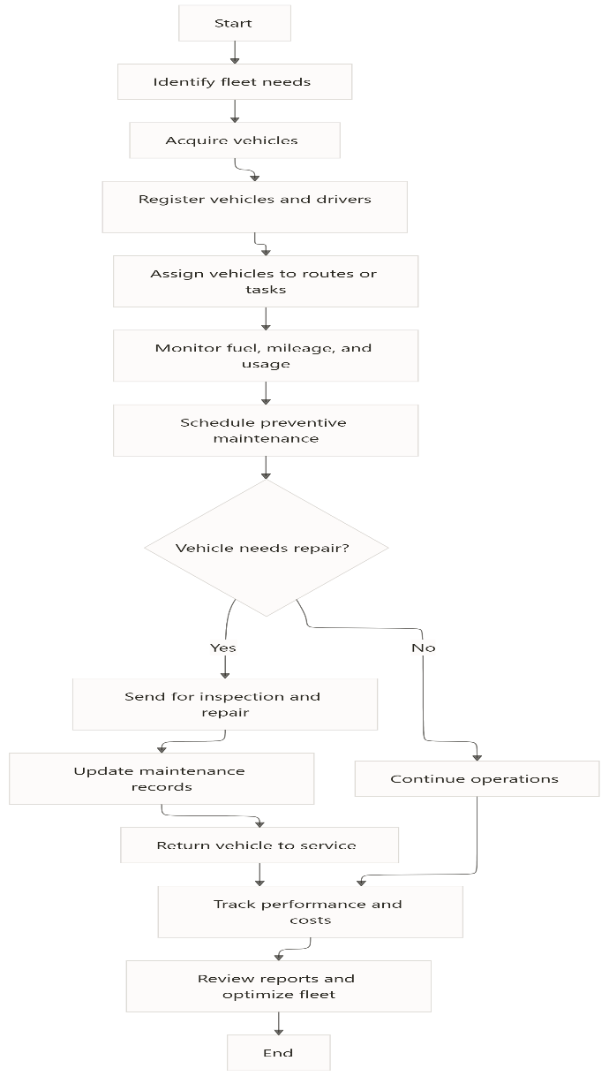

Fig 4.7 Fleet Management Flowchart
Main steps:
- Administrator adds/updates vehicles and drivers.
- Administrator creates routes and schedules.
- System assigns vehicle and driver to each schedule.
- After trip completion, staff or driver updates trip log (mileage, fuel, remarks).
- System generates reports on fleet utilization, fuel consumption, and maintenance needs.
4.6 User Interface Design (Overview)
You can include sample wireframes or descriptions for:
- Home page with search form
- Customer dashboard (upcoming trips, history)
- Booking form page
- Admin dashboard (KPIs, quick links)
- Fleet management screens (vehicle list, route management)

CHAPTER FIVE: SYSTEM DESIGN
5.0 Introduction
This chapter presents the design of the proposed Kukena SACCO Fleet Management and Online Transport Booking System. System design translates the requirements identified during system analysis into a practical system structure, interface, database, and operational processes. The design focuses on making the system simple, secure, reliable, user-friendly, and efficient for customers, staff, and administrators. The proposed system uses a web-based three-tier architecture consisting of the presentation, application, and data layers.

5.1 System Architecture Design
The system uses a three-tier architecture:
- Presentation Layer – This is the user interface accessed through computers, tablets, and smartphones. Customers, staff, and administrators interact with the system through web browsers.
- Application Layer – This layer contains the business logic responsible for booking, payment processing, vehicle management, schedules, authentication, and reporting.
- Data Layer – This layer stores system information such as customers, staff, vehicles, routes, schedules, bookings, payments, and system records.
The architecture allows information to move securely between the user's browser, application server, database server, and external services

5.1.2 Simple Architecture Sketch
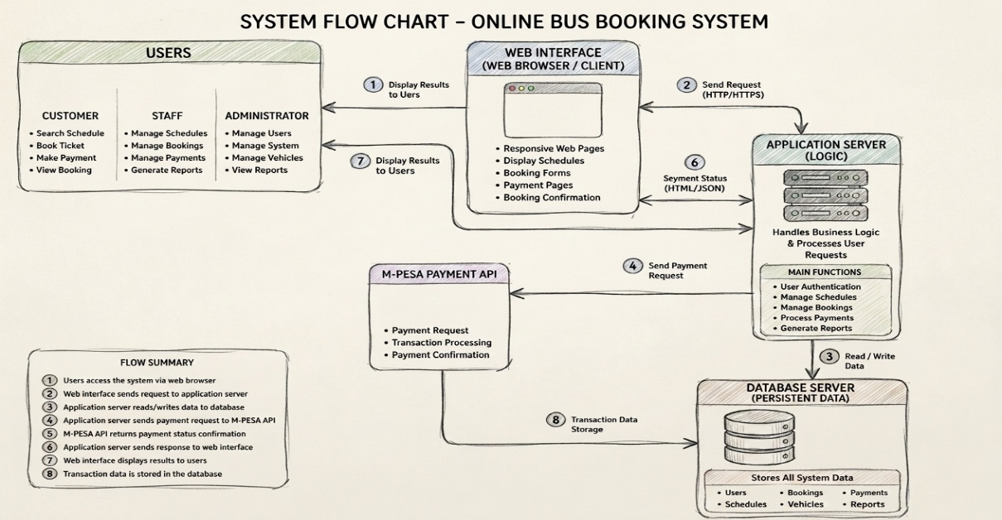

Figure 5.1.2 Simple Architecture Sketch

5.2 User Interface Design
The user interface is designed to provide an easy and understandable way for users to interact with the system. The design uses clear menus, buttons, forms, icons, tables, and dashboards.
The proposed system has different interfaces depending on the user's role. These include the customer interface, staff interface, and administrator interface. The project document identifies the home page, customer dashboard, booking form, administrator dashboard, and fleet management screens as important interfaces.

5.2.1 Customer Login and Registration Interface
The customer account portal allows an existing customer to log in using an email address or phone number and password. New customers can use the registration section to create an account.
The registration form contains:
- Full name
- M-Pesa phone number
- Email address
- Password
- Create Account button
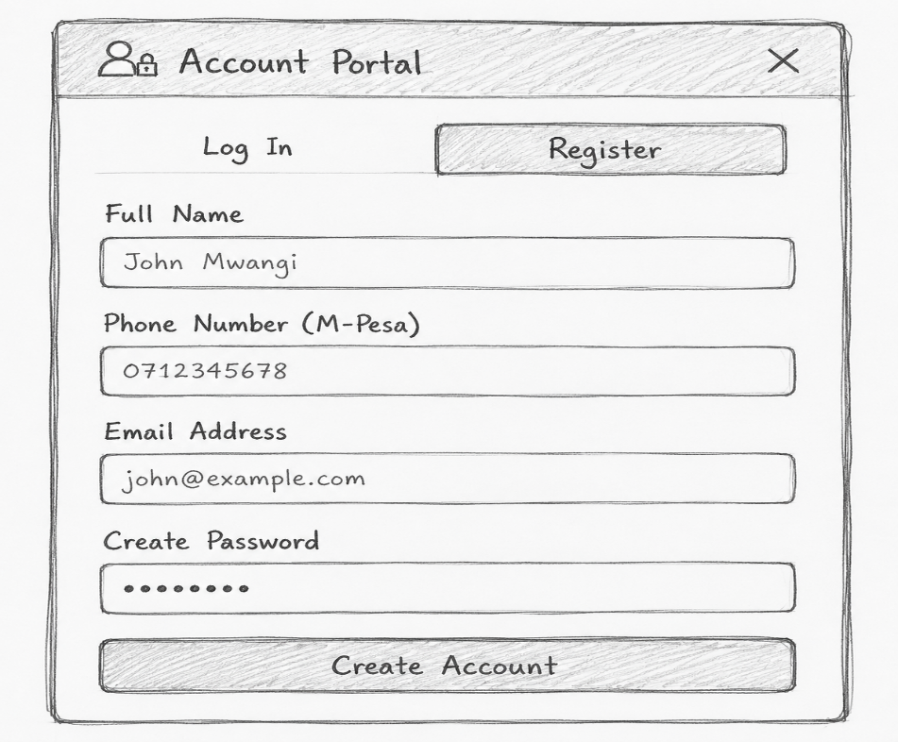

Figure 5.2.1 Customer Registration Interface

The login form contains:
- Email or phone number
- Password
- Sign In button
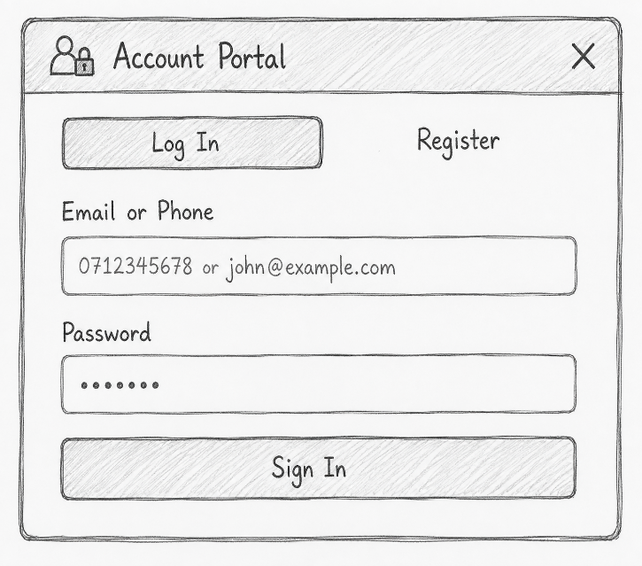

Figure 5.2.2 Customer Login Interface
This interface supports customer authentication before accessing booking and account services. The proposed system requires customers to register and log in before using protected services.

5.2.2 Customer Home (Customer Landing Page) and Booking Interface
The customer homepage provides a Quick Shuttle Search facility. A customer can select:
- Departure terminal
- Destination terminal
- Travel date
- Search Available Seats
The booking interface then displays available shuttles and schedules. Customers can select their preferred trip and available seats before proceeding to payment.

5.2.2 Customer Home (Customer Landing Page) and Booking Interface
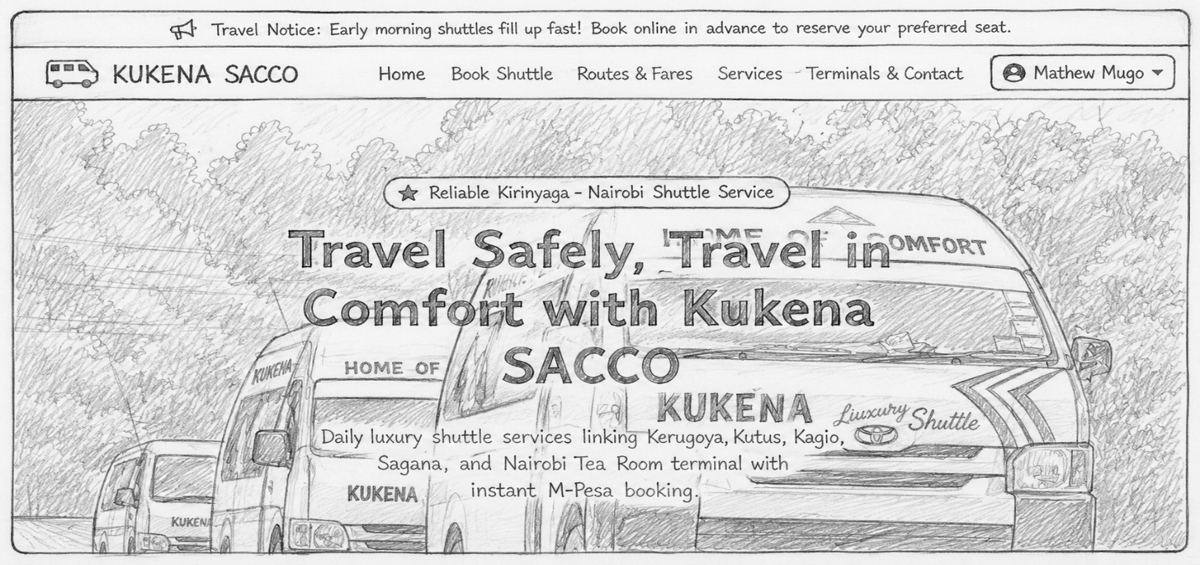

Figure 5.2.3 Customer Home (Customer Landing Page) and Booking Interface

5.2.4 Customer Booking Interface
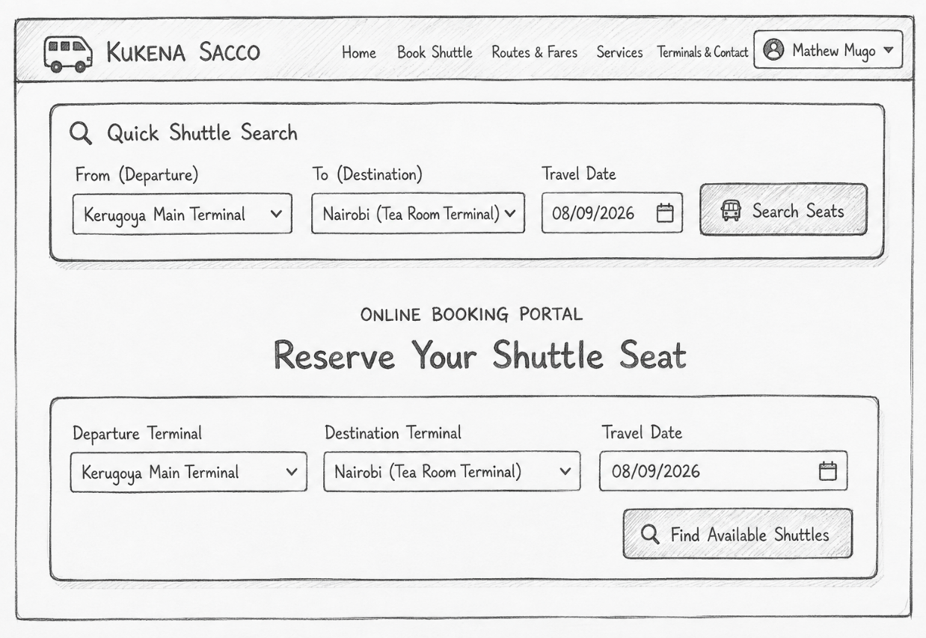

Figure 5.2.4 Customer Booking Interface

5.2.5 The main booking process
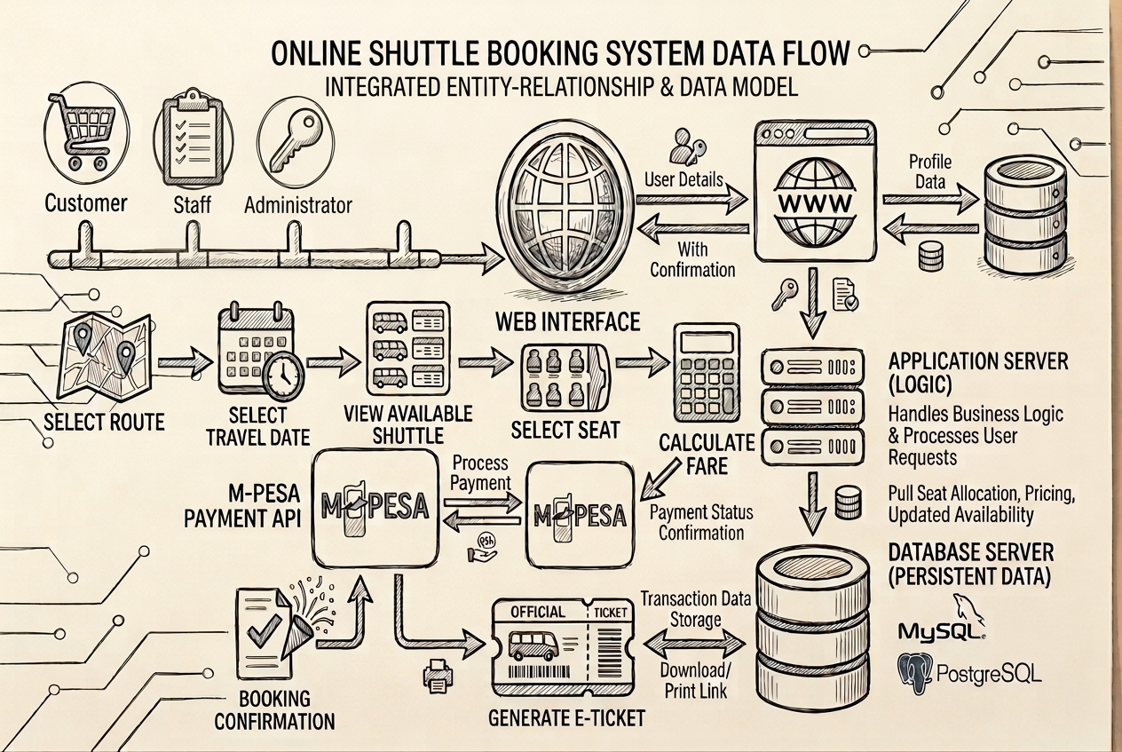

Fig 5.2.5 The main booking process

5.2.3 Staff Authentication Interface
The staff authentication interface provides secure access to the terminal operations section.
The staff member selects:
- Staff account
- Assigned terminal station
- Four-digit security PIN
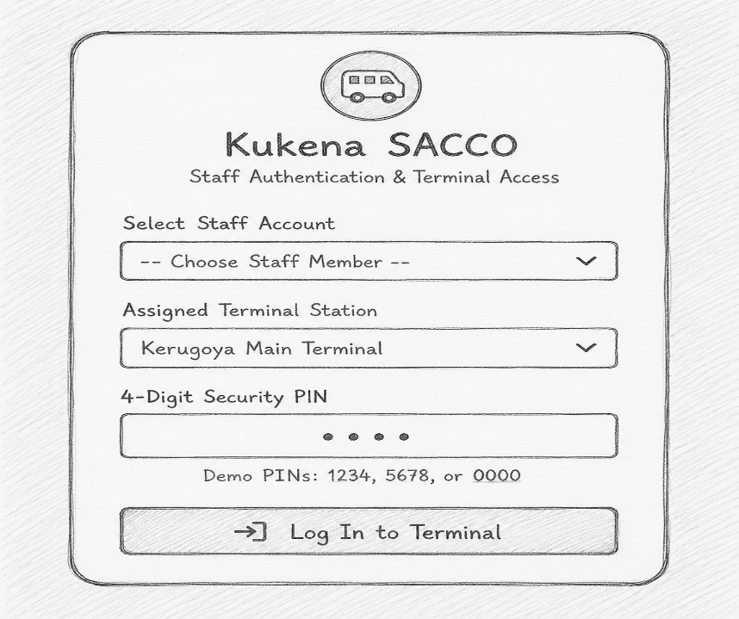

Figure 5.2.6 Staff Authentication Interface

After successful authentication, the staff member is taken to the Terminal Operations Dashboard.
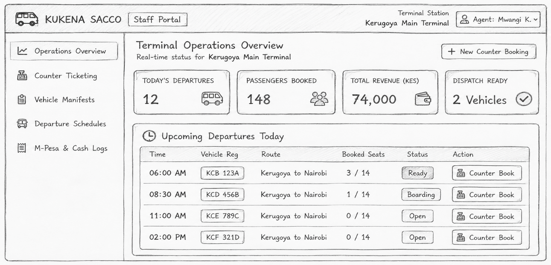

Figure 5.2.7 Staff Landing Interface
The purpose of this interface is to prevent unauthorized personnel from accessing booking, manifest, schedule, and payment functions.

5.3 Administrator Dashboard Design
The administrator dashboard provides centralized control over the transport booking and fleet management system.
The dashboard displays key performance indicators such as:
- Today's revenue
- Total passengers
- Active shuttles
- Average load factor
- Recent M-Pesa ticket bookings
- Dispatch quick actions
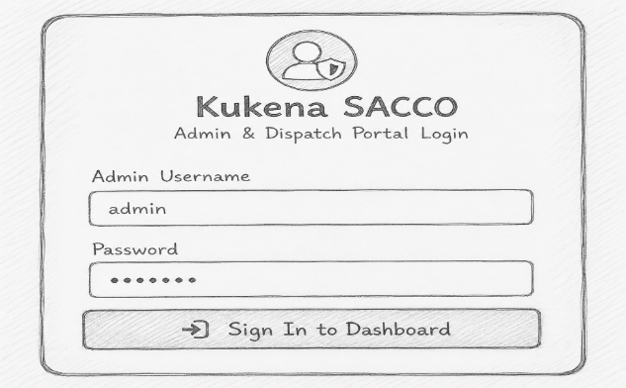

Figure 5.3.8 Admin Log In Interface

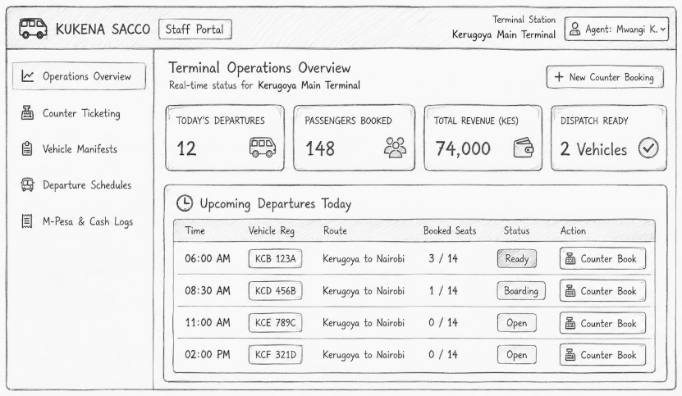

Figure 5.3.9 Admin Landing Interface
The administrator can also access:
- Dashboard
- Manage Trips
- All Bookings
- Vehicle Manifest
- Sign Out

5.4 Database Design
The database is designed to store and organize all information required by the system. The major entities include:
- CUSTOMER
- STAFF
- VEHICLE
- SCHEDULE
- BOOKING
- PAYMENT
- DRIVER
The relationships include one customer having many bookings, one schedule having many bookings, and vehicles and routes being associated with multiple schedules.

5.4.1 Simplified Database Structure
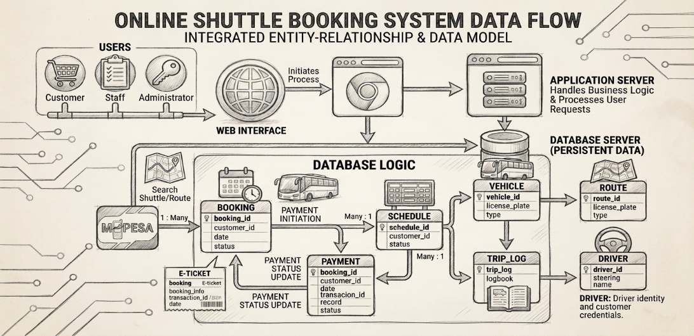

Figure 5.4.0 Simplified Database Structure
Primary keys and foreign keys are used to maintain relationships and data integrity. Vehicle registration numbers, for example, should be unique.

5.5 System Modules
The system is divided into several modules to make development and management easier. The major modules are:

a) User Management Module
Manages customer, staff, and administrator accounts, including registration, login, authentication, and authorization.

b) Booking Module
Allows customers and staff to search schedules, check seat availability, make bookings, and manage reservations.

c) Fleet Management Module
Allows administrators to manage vehicles, drivers, routes, schedules, and trip records.

d) Payment Module
Handles M-Pesa and other supported payment transactions and records payment information.

e) Reporting Module
Generates information concerning bookings, revenue, fleet utilization, payments, and operations.
These modules correspond with the project's identified key modules: user management, booking, fleet management, payment processing, and reporting/analytics.

5.6 Security Design
Security is important because the system handles customer information, staff accounts, bookings, and financial transactions.
The system will therefore use:
- Username/password authentication
- Staff PIN authentication
- Role-based access control
- Password protection
- Input validation
- Secure database access
- HTTPS communication
- Data encryption
- Secure M-Pesa integration
- Regular database backups
- Session management
The project specifically identifies authentication and authorization, data encryption, secure payment integration, and regular backups as security measures.

5.7 Implementation Environment
The proposed system can be implemented using a web server, database server, and client devices. The project specifies Linux or Windows Server, Apache or Nginx, PHP/Laravel or Node.js, MySQL or PostgreSQL, and modern browsers such as Chrome, Firefox, or Edge.
The development tools include:
- HTML5
- CSS3
- JavaScript
- PHP
- MySQL
- Apache
- WampServer
- Visual Studio Code
- Git/GitHub

5.8 System Testing Design
Testing will be carried out to ensure that the system works correctly before deployment.
The main testing methods include:
- Unit testing – tests individual functions.
- Integration testing – tests whether modules work together.
- System testing – tests complete workflows.
- User Acceptance Testing (UAT) – allows selected customers and Kukena staff to evaluate the system.
Examples of test cases include:
- Successful booking and payment.
- Booking when all seats are occupied.
- Preventing two customers from booking the same seat.
- Failed payment transaction.
- Unauthorized access to administrator functions.

5.9 Deployment and Maintenance
After successful testing, the system will be deployed to a production server. Deployment involves configuring the web server and database, migrating the database, configuring the domain and SSL certificate, and integrating the live M-Pesa credentials.
Regular maintenance will be required to:
- Fix system errors.
- Update security measures.
- Back up the database.
- Improve system performance.
- Add new features.
- Maintain compatibility with browsers and payment services.

5.10 Chapter Summary
Chapter Five has presented the design of the proposed Kukena SACCO Fleet Management and Online Transport Booking System. The design includes the system architecture, customer interface, staff portal, administrator dashboard, database structure, system modules, security measures, implementation environment, testing, deployment, and maintenance. The interface sketches provided show how the major system screens will appear and how customers, staff, and administrators will interact with the system. The design therefore provides a practical blueprint for the coding and implementation stage.

CHAPTER SIX: SYSTEM TESTING AND IMPLEMENTATION
This chapter presents the tools used for coding and testing, the system test plan, and the proposed changeover technique for the new system. It explains how the software was prepared, verified, and planned for deployment in a way that supports reliability and user acceptance.

6.1 Tools Used for Coding and Testing
The system was developed using standard programming and testing tools suitable for building, debugging, and validating the application. Coding tools typically include a code editor or integrated development environment, a database management system for storing and retrieving data, and version control software for tracking changes during development.
For testing, the project used manual test case design, test data preparation, and result comparison against expected outputs. Debugging tools, browser developer tools where applicable, and database query tools were used to inspect behavior, verify records, and confirm that modules interacted correctly.

6.2 System Test Plan
The system test plan was designed to evaluate the complete application from the user’s perspective using black-box testing. The main objective was to confirm that the software performs the required functions correctly, produces the expected outputs, and handles common user scenarios without.

6.3 Data Used for Testing
The test data included valid, invalid, and boundary inputs to verify how the system responds under different conditions. Valid data was used to confirm normal operation, invalid data was used to check error handling, and boundary data was used to test limits such as minimum and maximum values, empty fields, and unusual but realistic user entries.
Typical test data categories included:
- Correct user inputs for normal transactions.
- Incorrect or incomplete inputs to test validation.
- Duplicate entries to test uniqueness rules.
- Boundary values to check system limits.
- Existing records in the database to confirm update, search, and retrieval functions.

6.4 Testing Approach
The approach followed a structured manual testing process. Each feature was tested against its expected behavior, and results were compared with the requirements and functional specification to ensure traceability. Tests were selected to cover important real-world scenarios rather than repeating similar cases unnecessarily.
The main testing activities were:
- Preparing test cases from the functional requirements.
- Creating test data for each case.
- Executing the tests manually.
- Recording actual results.
- Comparing actual and expected outcomes.
- Reporting defects for correction.
- The system test focused on end-to-end functionality, including data entry, processing, output generation, and error messages. This ensured that the software worked as a complete product rather than only as separate modules.

6.5 Proposed Changeover Techniques
A changeover technique describes how the old system is replaced by the new one. The most suitable techniques are direct changeover, parallel changeover, phased changeover, and pilot changeover, each with different levels of risk and control.
For this project, the recommended technique is phased changeover because it allows the system to be introduced gradually, module by module, reducing disruption and making it easier to detect and fix problems early. This approach is safer than direct changeover and less costly than running both systems fully in parallel for a long period.
The advantages of phased changeover include:
- Lower risk of total system failure.
- Easier training for users.
- Better control over errors during rollout.
- Ability to correct issues before full deployment.
- A backup plan should also be kept ready during the transition period so that operations can continue if any major issue occurs. This makes the implementation more stable and helps users adapt to the new system smoothly.

CHAPTER SEVEN: LIMITATIONS, CONCLUSIONS, AND RECOMMENDATIONS
This chapter presents the limitations encountered during the development of the new system, the conclusions drawn from the project, and recommendations for improving the system in future. It provides a brief closing assessment of the work and highlights areas that can be strengthened after implementation.

7.1 Limitations
The development and testing of the new system were affected by a number of limitations. Common project limitations include time constraints, limited financial resources, technical challenges, and incomplete or delayed responses during data collection and evaluation.
One major limitation was the restricted time available for full testing and refinement of all system features. This may have limited the extent to which the system was tested under all possible user conditions and exceptional cases.
Another limitation was the possibility of limited user feedback during development. When users are unavailable or slow to respond, it becomes harder to capture all practical requirements and expectations, which can affect final system usability.
Technical constraints such as hardware performance, software compatibility, and data migration issues may also have influenced the completeness of the implementation. These factors can delay deployment or reduce the speed of system optimization.

7.2 Conclusions
The new system was developed to improve efficiency, accuracy, and reliability in carrying out the intended tasks. Based on the design and testing carried out, the system is considered capable of meeting its basic functional requirements and supporting the intended operations.
The project also showed that careful planning, testing, and phased implementation are important in reducing errors and improving user acceptance. The results indicate that the system can replace manual or less efficient procedures with a more organized and dependable process.
Overall, the system provides a practical solution to the identified problem and offers a foundation for future improvements. Its structure and functionality demonstrate that it can be expanded as more user needs and operational demands emerge.

7.3 Recommendations
It is recommended that the system be improved through regular updates, more extensive testing, and continued user training. These measures will help increase reliability and ensure that users can operate the system effectively.
Further enhancements should focus on expanding system features, strengthening data validation, and improving reporting functions where necessary. Additional testing with more real-world data would also help reveal issues that may not have appeared during initial implementation.faculty.cs.byu+1
The organization should also maintain backup procedures and a support plan during the early stages of use. This will help minimize disruption if technical problems arise after deployment.
Future development should consider integration with other systems, automation of more tasks, and improved security controls. These changes would make the system more robust and better suited to long-term use.

7.4 Summary
This chapter has outlined the main limitations of the project, summarized the conclusions reached after development and testing, and presented recommendations for improving the system. It closes the study by showing that, although the new system is useful and functional, continued refinement is important for long-term success.

REFERENCES
- Bhroin, N. N., Sand, S., & Rasmussen, T. (2021). Indigenous journalism, media innovation, and social change. Nordicom Review, 42(2), 185–206. https://doi.org/10.2478/nor-2021-0050columbiacollege-ca.libguides
- FleetVision: An integrated fleet operations and maintenance management system. (2024). International Research Journal of Engineering and Technology, 13(4), 1–8.irjet
- Fleet management system architecture. (2026). Williams Devos Documentation. mintlify
- Fleet management system. (2021). International Journal of Advance Research and Innovative Ideas in Education, 7(3), 1000–1008.ijariie
- Use case diagram for bus reservation system. (2025). EdrawMax Templates. edrawmax
- DuBois, P. (2021). MySQL (5th ed.). Addison-Wesley Professional.
- Duckett, J. (2021). HTML and CSS: Design and Build Websites. Wiley.
- Nixon, R. (2021). Learning PHP, MySQL & JavaScript (6th ed.). O'Reilly Media.
- Pressman, R. S., & Maxim, B. R. (2020). Software Engineering: A Practitioner's Approach (9th ed.). McGraw-Hill Education.
- Rodrigues, J. (2021). Fleet Management Systems and Transportation Technologies. International Journal of Transportation Systems, 15(2), 45-58.
- Safaricom PLC. (2025). M-Pesa Business Integration Documentation.
- Sommerville, I. (2016). Software Engineering (10th ed.). Pearson Education.
- International Journal of Advance Research and Innovative Ideas in Education (IJARIIE). (2021). Fleet Management System. IJARIIE, 7(3), 1000-1008.

APPENDICES

Appendix A: Sample Questionnaire (Requirements Gathering)
Include a structured questionnaire for customers and staff. Example items:
Section A: Demographic Information
- Age:
- Gender:
- Role: Customer / Staff / Driver
Section B: Current Booking Experience
- How do you currently book trips with Kukena Sacco?
- What challenges do you face with the current booking process?
Section C: System Requirements
- Which features would you like to see in an online booking system (e.g. seat selection, mobile payment, SMS confirmation)?
- How important is 24/7 booking access to you? (1–5 scale)

Appendix B: Sample Screenshots (To be added after prototype)
- Home page with route search
- Booking form
- Payment confirmation screen
- Admin dashboard
- Vehicle management screen

APPENDICES

Appendix A: Organizational Structure

Table A.1: Organizational structure of the system development team
Role | Responsibility
Project Sponsor | Approves scope, budget, and key decisions.
System Analyst | Defines requirements and validates the system design.
Developer | Codes, integrates, and maintains the system modules.
Tester | Prepares and executes test cases and reports defects.
End User | Uses the system and provides feedback for improvement.
Figure A.1: Organizational structure of the project team
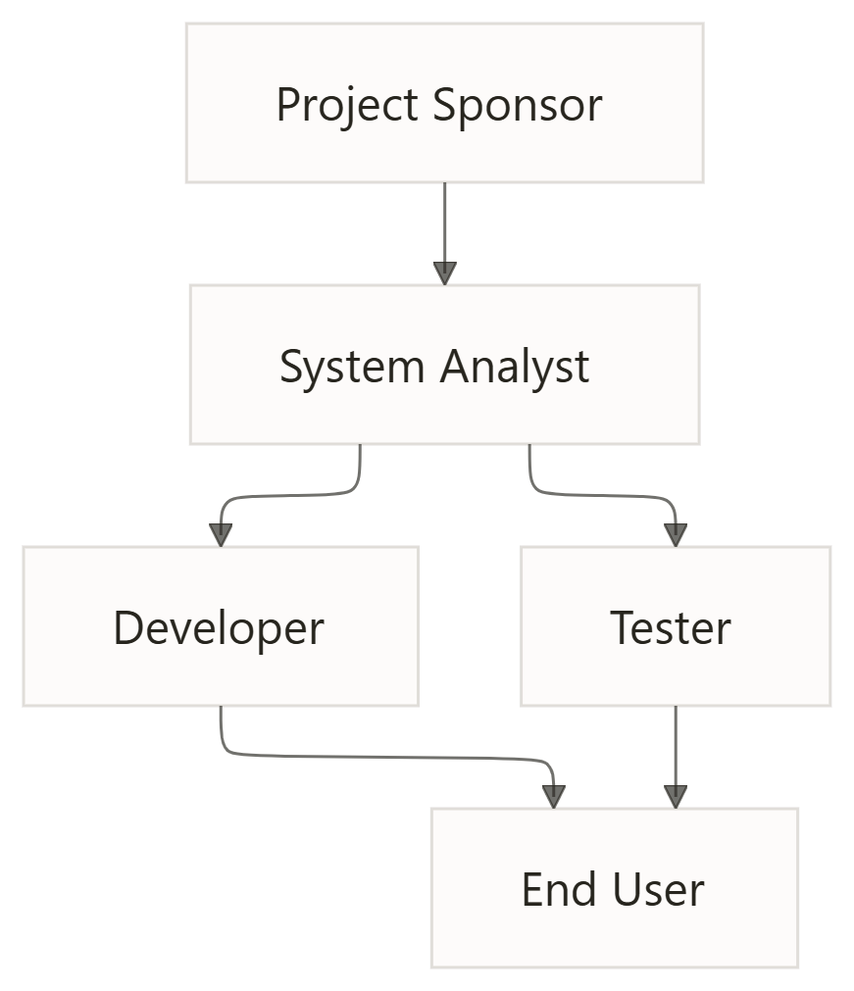

Appendix B: Documents Reviewed

Table B.1: Documents reviewed during system development
Document | Purpose
Requirements Specification | Defines system functions, constraints, and user needs.
System Design Document | Describes architecture, modules, inputs, outputs, and data flow.
Test Plan | Lists test cases, test data, and expected results.
User Manual Draft | Provides instructions for end users.
Technical Guide Draft | Provides installation, configuration, and maintenance guidance.

Appendix C: Technical Guide

C.1 System Setup

Table C.1: Technical setup requirements
Item | Description
Installation | Install the application, database, and required dependencies.
Configuration | Set database connections, system parameters, and access rights.
Verification | Confirm that the system starts correctly and connects successfully.

C.2 Maintenance Guide

Table C.2: Technical maintenance procedures
Item | Description
Backup | Perform regular backups of application and database files.
Update | Apply bug fixes, enhancements, and version upgrades.
Recovery | Restore system files and data in case of failure.
Monitoring | Review logs, performance, and error messages regularly.

Figure C.1: Technical workflow for system setup and maintenance

INSTALL SYSTEM
CONFIGURE DATABASE
TEST CONNECTION
DEPLOY MODULE
MONITOR LOGS
BACKUP AND RECOVERY

Appendix D: User Manual

D.1 Basic User Tasks

Table D.1: User manual operating procedures
Task | Procedure
Login | Enter the username and password, then access the dashboard.
Add Record | Open the form, fill in the required fields, and save.
Search Record | Use the search function to locate the required record.
Update Record | Open the record, edit the details, and save the changes.
Generate Report | Select the report type, apply filters, and export or print.
Logout | Close the session securely after completing the work.

Figure D.1: User process flow
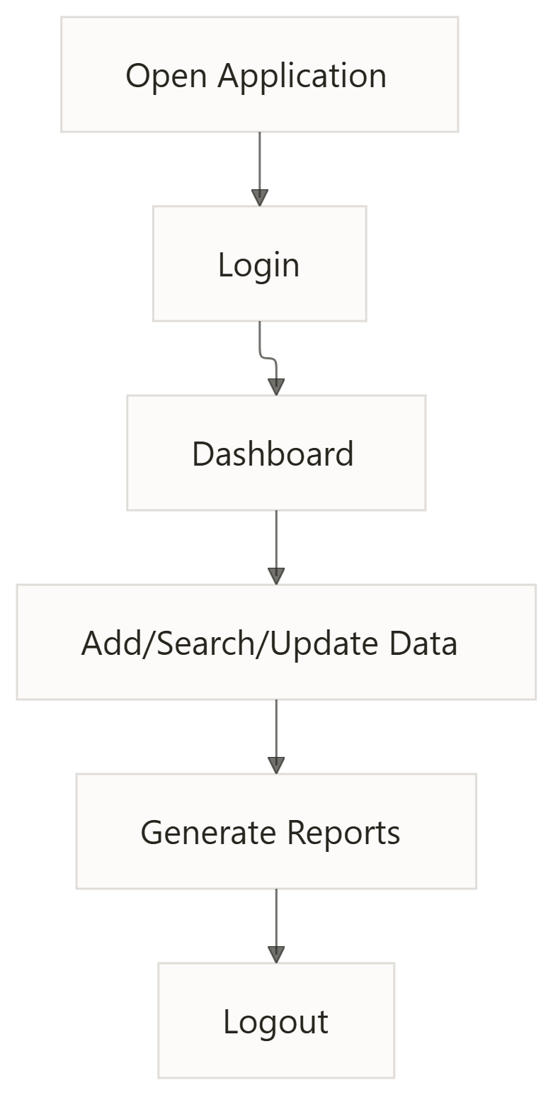

Appendix E: Test Data Summary
Table E.1: Summary of test data used in system testing
Test Type | Example Data | Expected Result
Valid Data | Correct entries | System accepts and saves the record.
Invalid Data | Missing or incorrect values | System displays an error message.
Boundary Data | Minimum and maximum values | System handles limits correctly.
Duplicate Data | Existing record values | System displays a duplicate warning.
Search Data | Existing and non-existing identifiers | System returns the correct result or no match found.

Appendix F: Graphics and Supporting Charts

Table F.1: Appendix content overview
Appendix | Content
Appendix A | Organizational structure
Appendix B | Documents reviewed
Appendix C | Technical guide
Appendix D | User manual
Appendix E | Test data summary
Appendix F | Graphics and supporting charts
Figure F.1: Appendix content structure
